

**American International University- Bangladesh**

**COE 3103: DATA COMMUNICATION**

**Mid Lab Assignment**

**Spring 2021-2022**

**Section: Q**

**Date: 15/03/2022**

**Submitted by,**

|  |  |
| --- | --- |
| Student Name | Student Id |
| Rahman, Sheikh Talha Jubayer | 19-41468-3 |

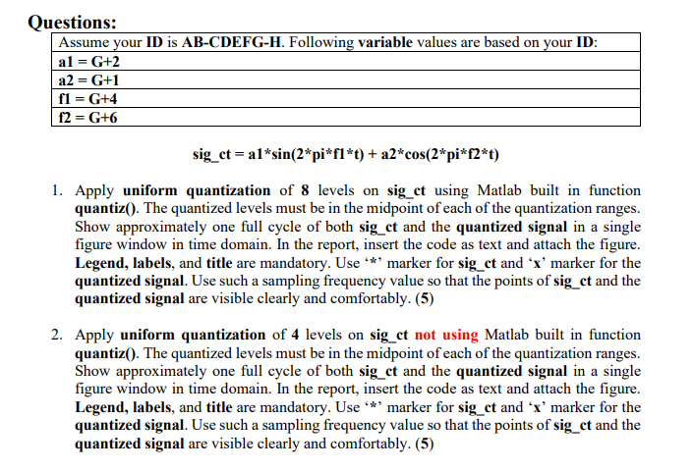

**Answer of Question 1**

%ID: 19-41468-3

A = 1;

B = 9;

C = 4;

D = 1;

E = 4;

F = 6;

G = 8;

H = 3;

a1 = G+2; %a1 = 8+2 = 10

a2 = G+1; %a2 = 8+1 = 09

f1 = G+4; %f1 = 8+4 = 12

f2 = G+6; %f2 = 8+6 = 14

fs = 8000;

t = 0:1/fs:1;

sig_ct = a1*sin(2*pi*f1*t) + a2*cos(2*pi*f2*t);

level = 8;

del = (max(sig_ct)-min(sig_ct))/level;

p = (min(sig_ct)+del):del:(max(sig_ct)-del);

c = (min(sig_ct)+(del/2)):del:(max(sig_ct)-(del/2));

[i,q] = quantiz(sig_ct,p,c);

plot(t,sig_ct,'*',t,q,'x');

axis([0 0.5 -20 20]);

title('Quantization Using Buit-In Function');

legend('Original signal','Quantized signal');

xlabel('Time (s)');

ylabel('Amplitude');

**Figure:**



**Answer of Question 2**

%ID: 19-41468-3

A = 1;

B = 9;

C = 4;

D = 1;

E = 4;

F = 6;

G = 8;

H = 3;

a1 = G+2; %a1 = 8+2 = 10

a2 = G+1; %a2 = 8+1 = 09

f1 = G+4; %f1 = 8+4 = 12

f2 = G+6; %f2 = 8+6 = 14

fs = 8000;

t = 0:1/fs:1;

sig_ct = a1*sin(2*pi*f1*t) + a2*cos(2*pi*f2*t);

level = 4;

Am = (max(sig_ct)-min(sig_ct))/2;

Nsamples = length(sig_ct);

quantised_out = zeros(1,Nsamples);

del = (2*Am)/level;

Llow = -Am+del/2;

Lhigh = Am-del/2;

for i=Llow:del:Lhigh

for j=1:Nsamples

if(((i-del/2)<=sig_ct(j))&&(sig_ct(j)<=(i+del/2)))

quantised_out(j)=i;

end

end

end

plot(t,sig_ct,'*',t,quantised_out,'x');

axis([0 0.5 -20 20]);

title('Quantization Using Manual Method');

legend('Original signal','Quantized signal');

xlabel('Time (s)');

ylabel('Amplitude');

**Figure:**

